N8n Home assignment
Home Assignment 2:

Build a Document Question Answering (Document QA) Agent

Develop an AI-powered Document QA agent that enables users to upload a document from their local system and ask questions based on its content. The agent should extract the document content, understand the user's query, and provide accurate answers using only the uploaded document as the source of information. If the requested information is not available in the document, the agent should respond appropriately instead of generating unsupported answers.

Expected Outcome: Users should be able to upload a document, ask multiple questions, and receive context-aware answers derived only from the uploaded document.

list of nodes :

1.Manua Trigger
2.Read /write files from disk
3.Extract from file
4.Basic LLM chain
Pre-requite :
Create a folder ‘.n8n-files’ in the below path where n8n is downloaded(already .n8n folder is present in the below path as it is downloaded)
C:\Users\rta
Place the file inside the new folder you created
C:\Users\rta\.n8n-files

If you don’t want to share the file to n8n as it is confidential, follow the below steps
- In windows search for ‘Edit the system environment variable’ and click on open.
- Click on ‘Environment variable button’
- Click on ‘New’ under ‘user variables for rta’
- Give the path where u had saved the document
C:\Users\rta\Pictures
Node 1 : Manual Trigger
- Click on ‘+’ icon on the right and search for ‘Manual Trigger’
- Select it and the node will be added successfully
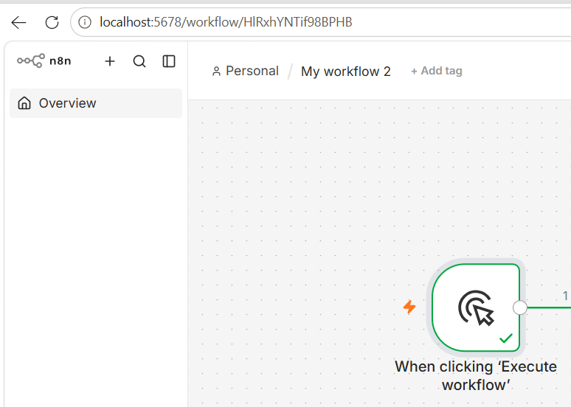

Node 2 : Read /write files from disk
- Click on ‘+’ icon on the right and search for ‘Read /write files from disk’
- Select ‘Read from disk’ and the node will be added successfully
- Double click on this node and give the path of the file where you have placed along with the name of the file.pdf as it is a pdf file.
C:\Users\rta\.n8n-files\Troubleshooting_ExecutionPolicy Issue.pdf
- Click on ‘Execute Step’
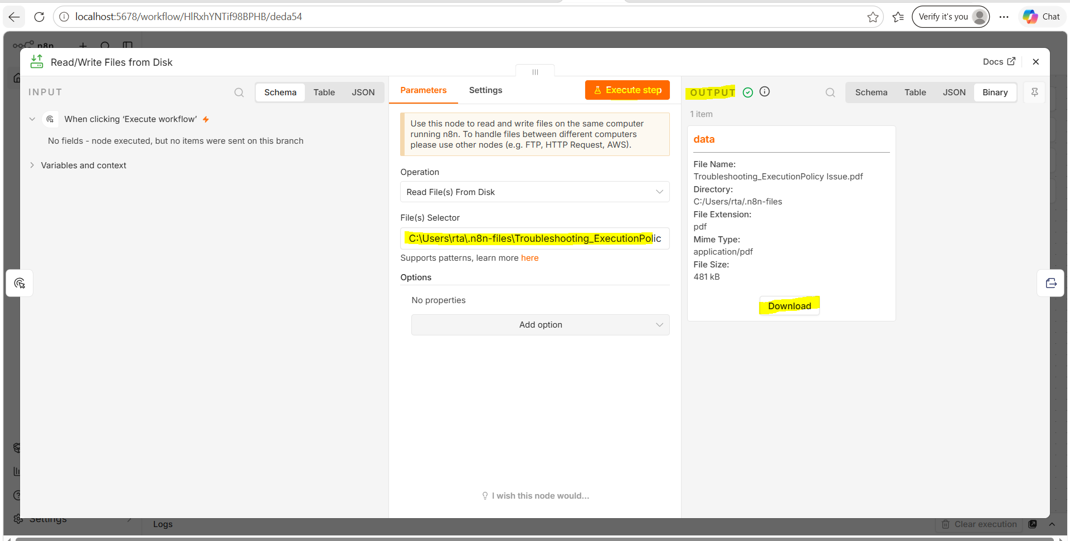
- Close the node

Node 3 : Extract from file
- Click on ‘+’ icon on the right and search for ‘Extract from file’
- Select it and the node will be added successfully
- Double click on the node
- Click on ‘Execute Step’
- Verify if the output has the ‘Text’ section to make sure the text from the given pdf document is read as shown in the below screenshot
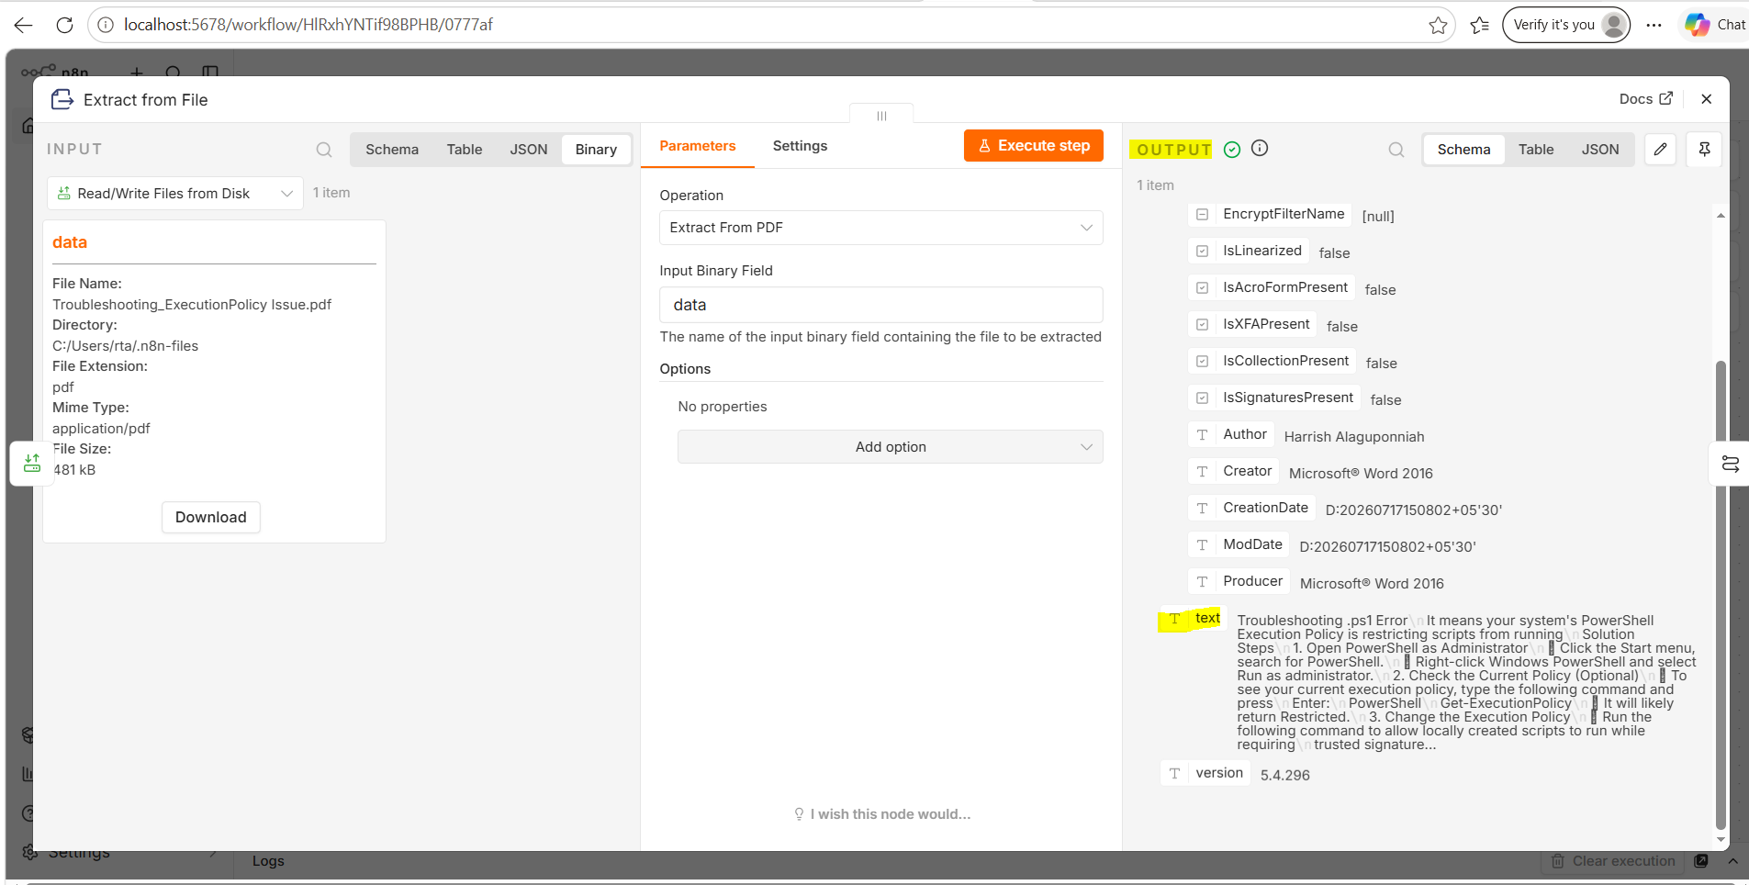
- Close the node

Node 4 : Basic LLM chain
- Click on ‘+’ icon on the right and search for ‘Basic LLM Chain’
- Select it and the node will be added successfully
- Double click on the node
- Select ‘Define Below’ from the drop-down
- Click on ‘Expression’ and give the below prompt

The agent should extract the document content, understand the user's query, and provide accurate answers using only the uploaded document as the source of information. If the requested information is not available in the document, the agent should respond appropriately instead of generating unsupported answers.
[Strict] Don’t generate responses based on the general knowledge. Dont hallucinate the details. Just answer only based on the document that is provided. If the question asked is not on the document, provide a message 'question asked is not relevant to the document'
Document Content : {{ $json.text }}
Input :
What is the issue mentioned in the document
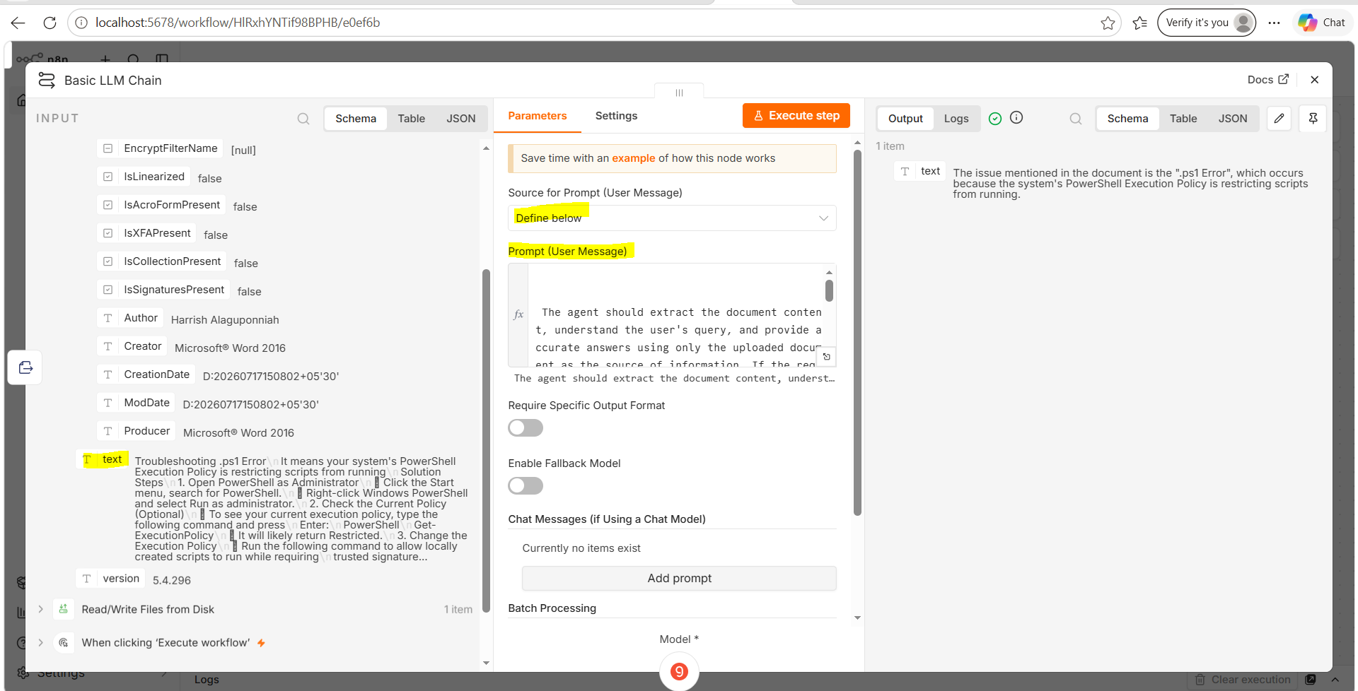

- Document Content : {{ $json.text }} (In the prompt)
Drag and drop the highlighted one from the left side where there is ‘Text’ as shown in the above screenshot
- Click on the delete icon on the left side of User field
- Click on ‘Execute Step’
- Relevant answers from the PDF should be displayed in the output
- Question in the prompt is ‘What is the issue mentioned in the document(given in the prompt).
- Answer is received in the output
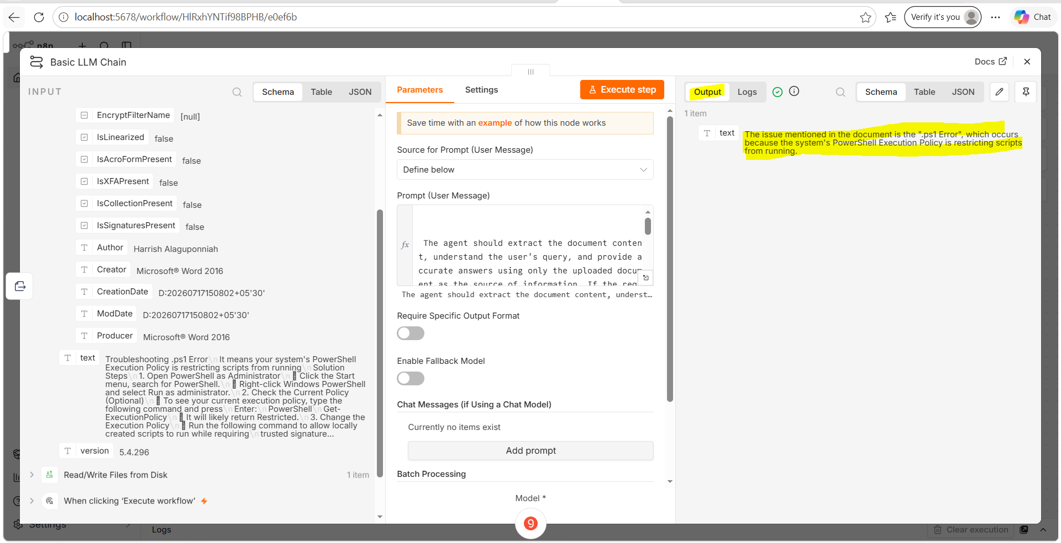
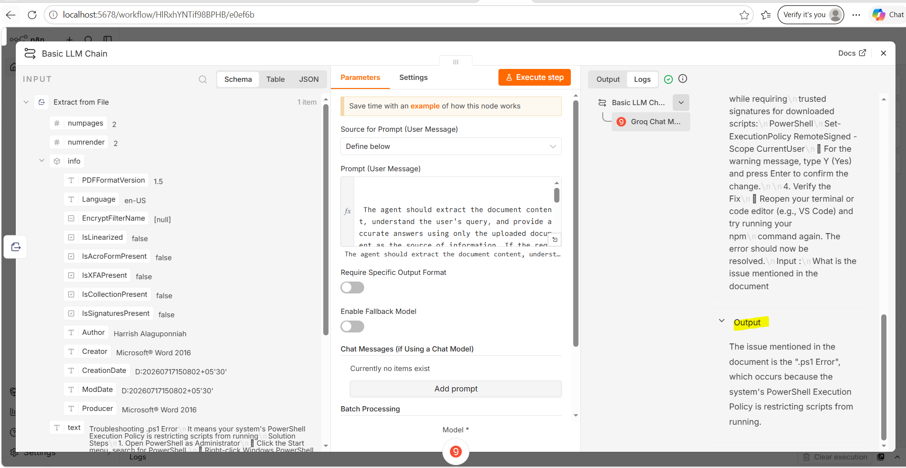
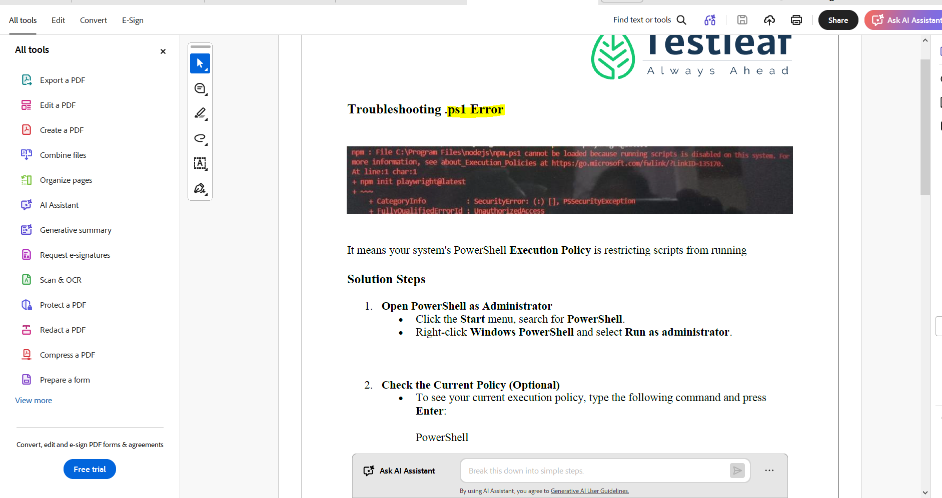

Node 5 : Groq chat model
- Click on ‘+’ icon on the right and search for ‘Groq’
- Select it and the node will be added successfully
- Double click on this node
- Create a new API key in ‘Console.groq’ website. Copy it and paste it in this node.
- Select the model as ‘llama-3.3-70b-versatile’
- Close this node
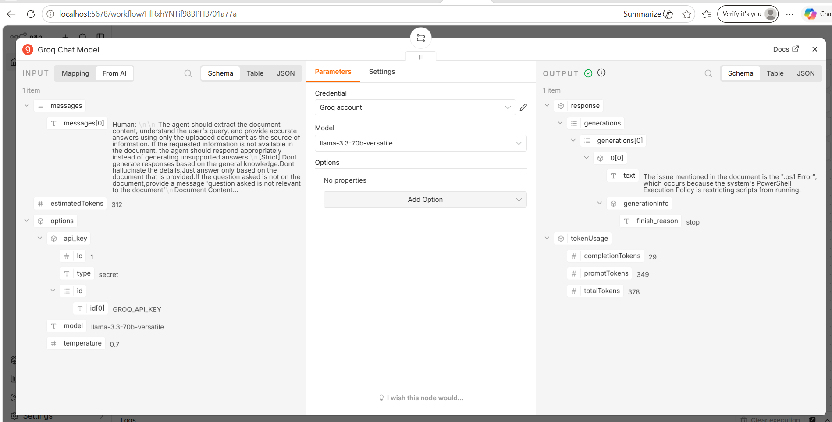
Overall Execution flow
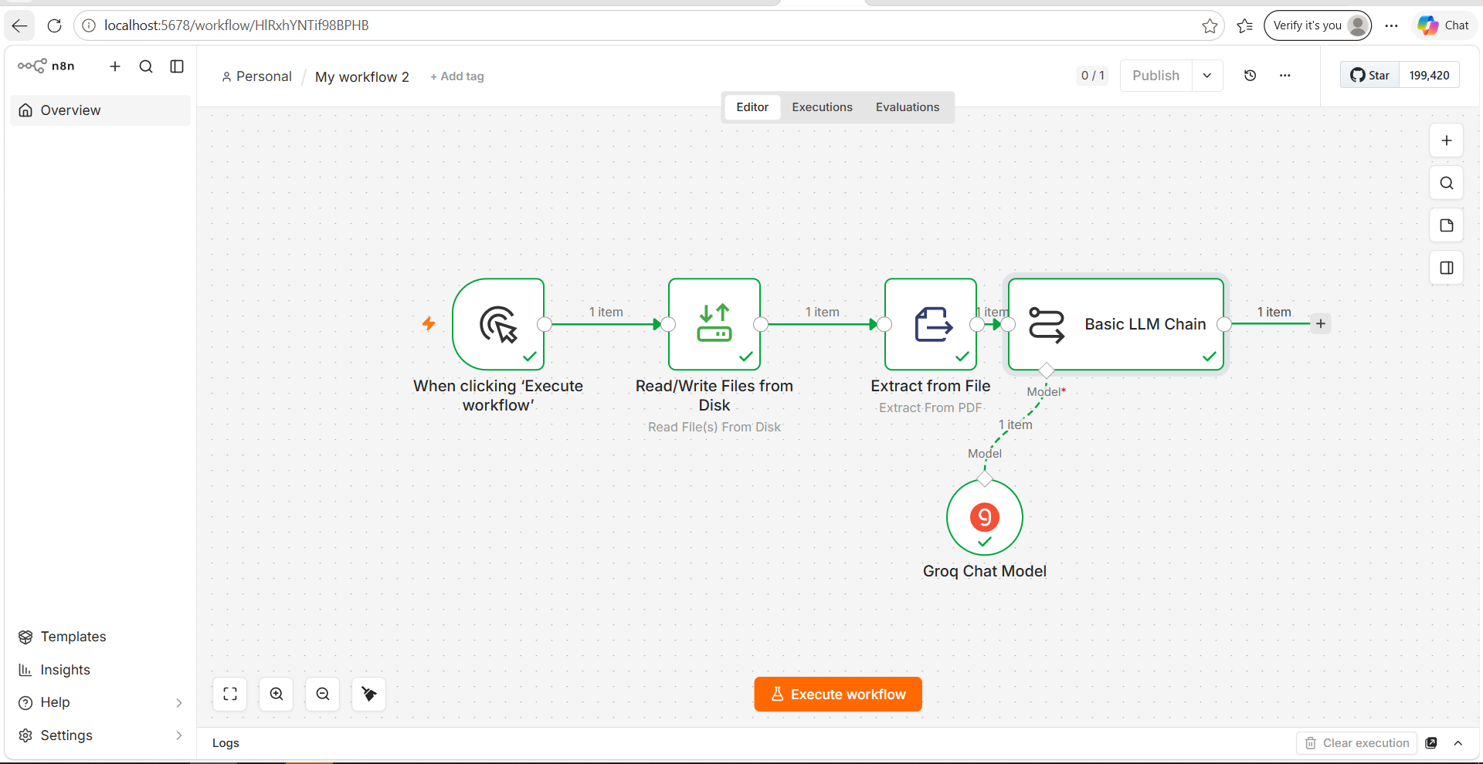
Additional Questions :
What is the first solution step given in the document to resolve the issue?
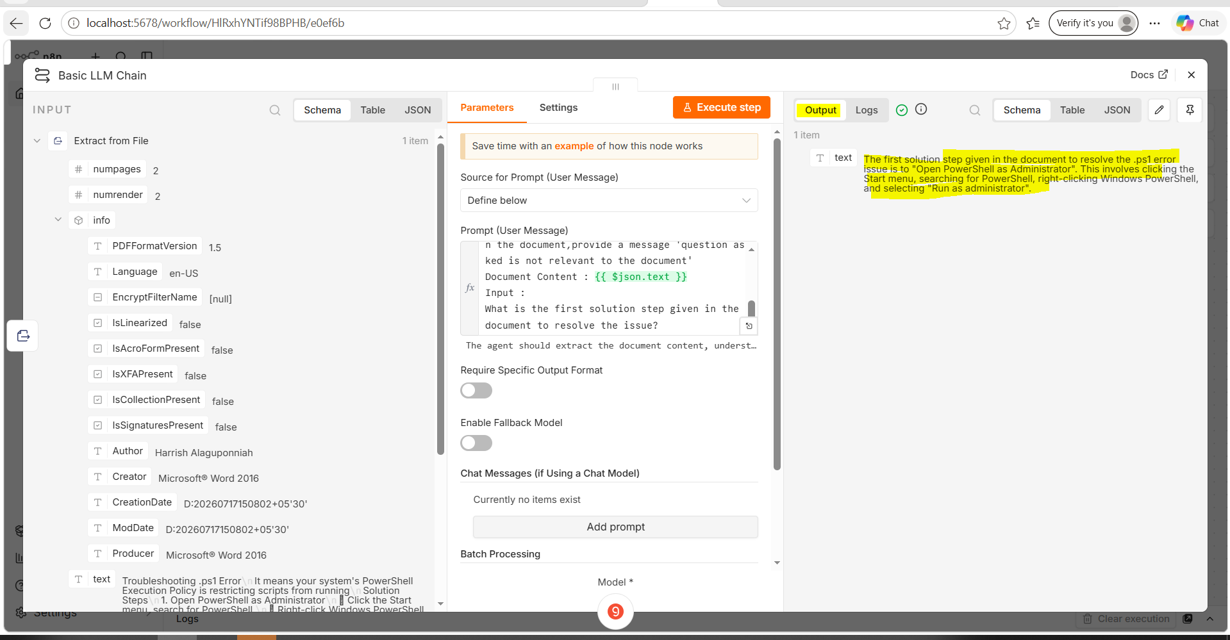
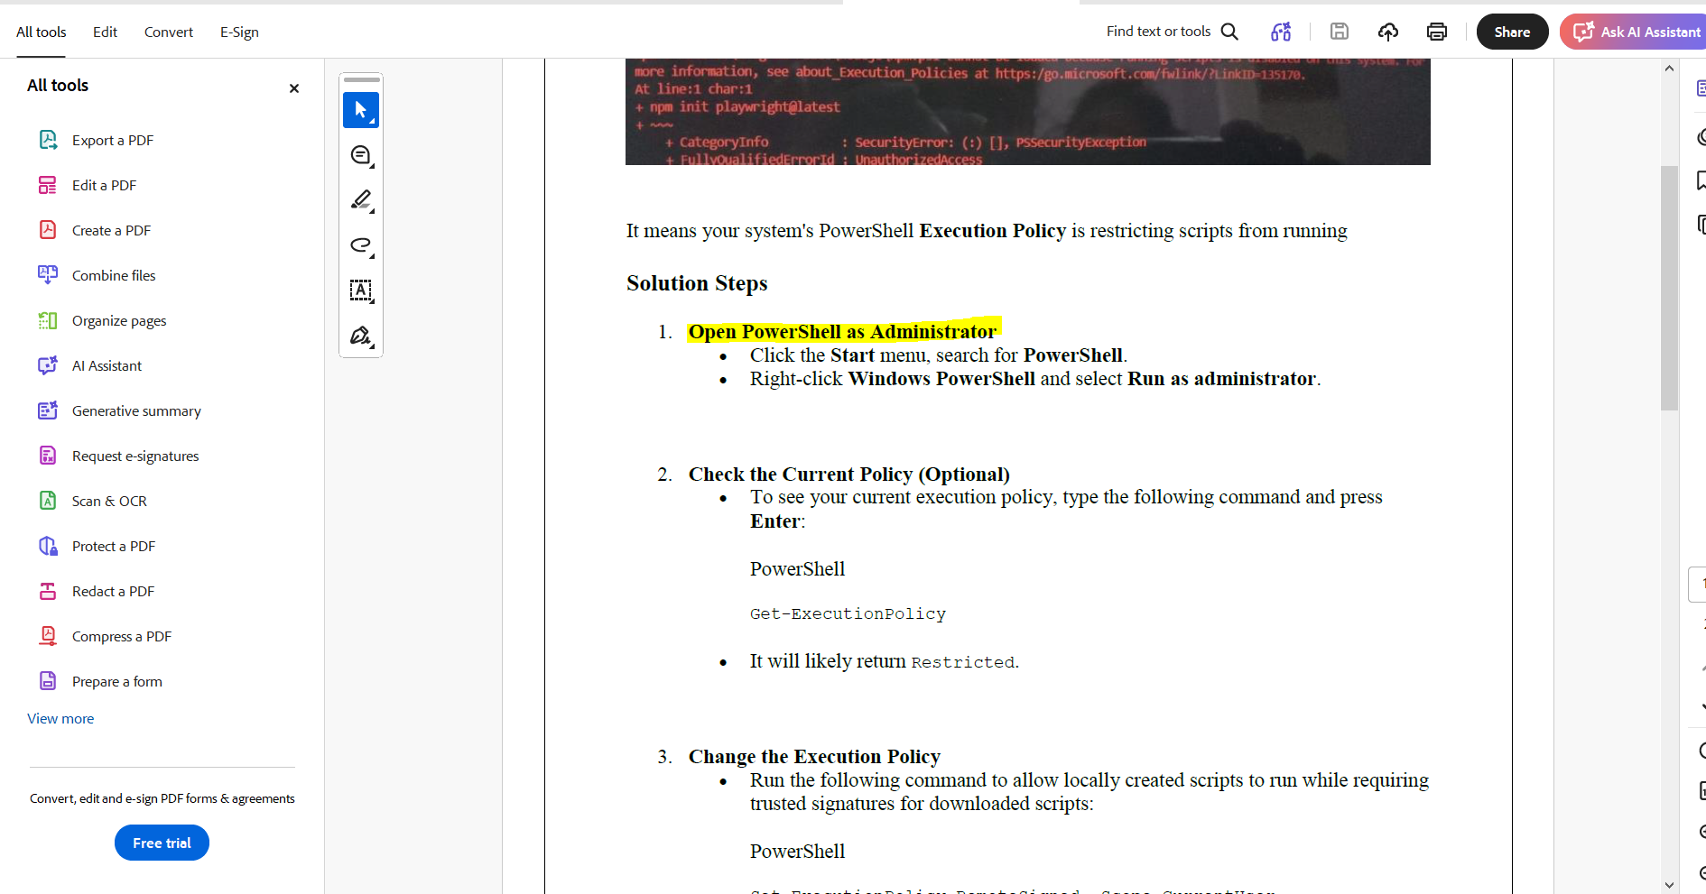

Which is the optional step mentioned in the document?
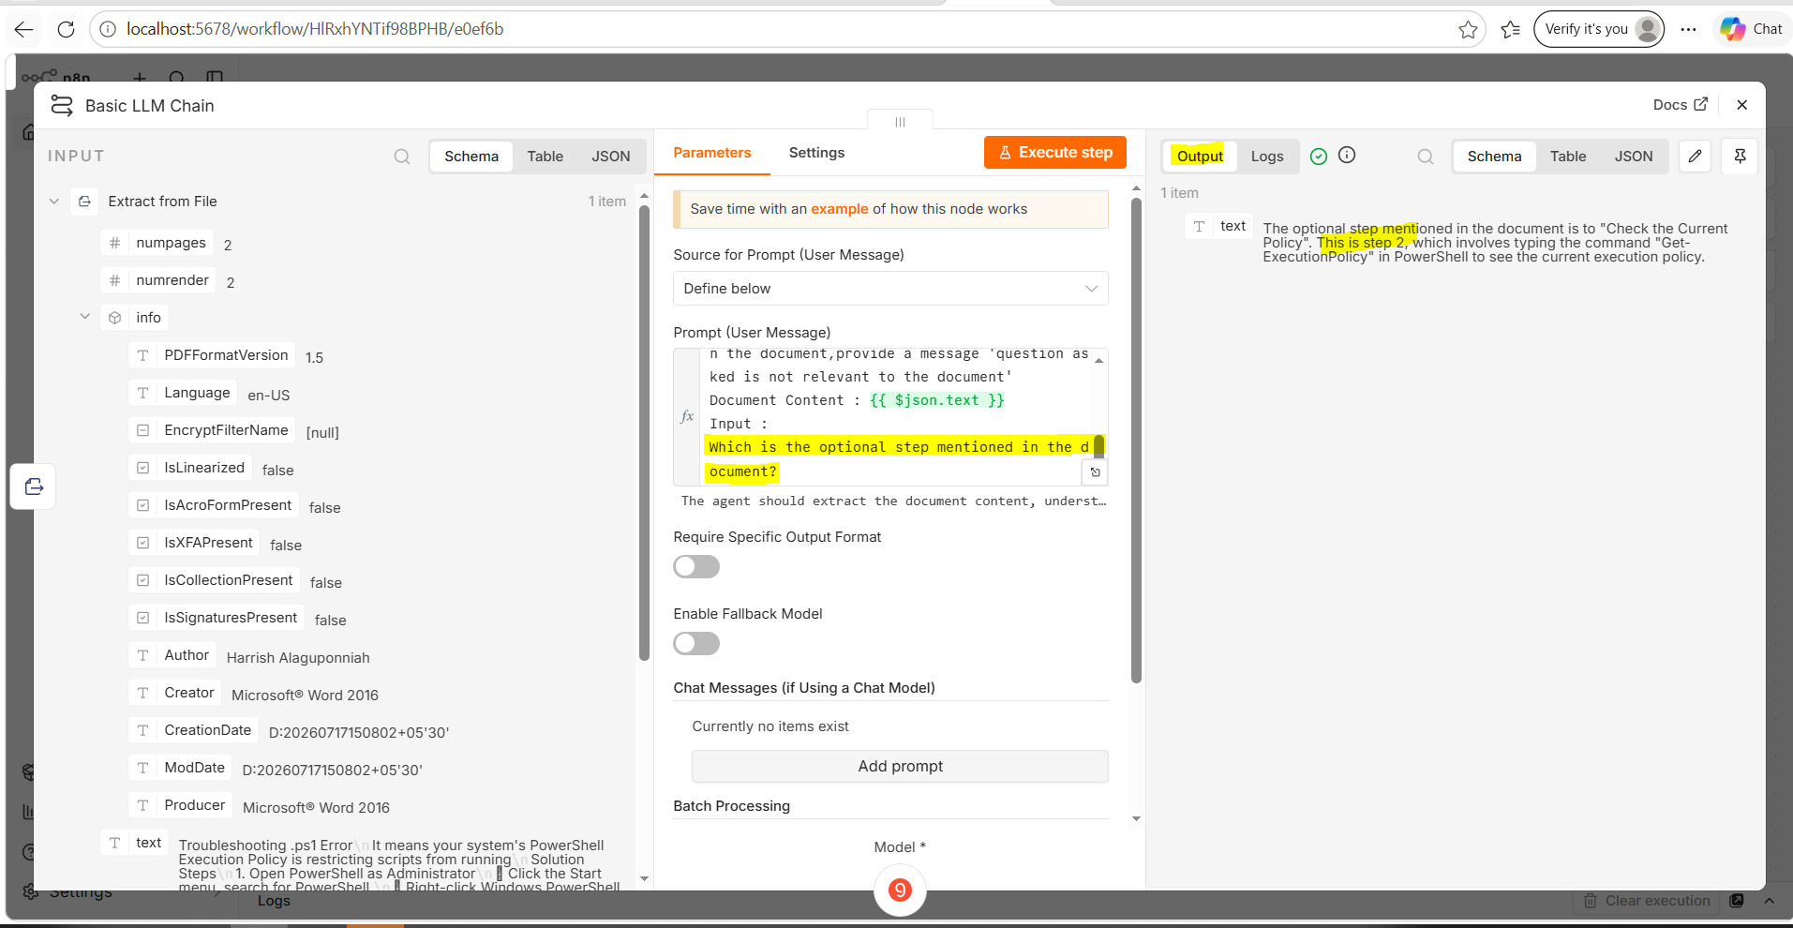
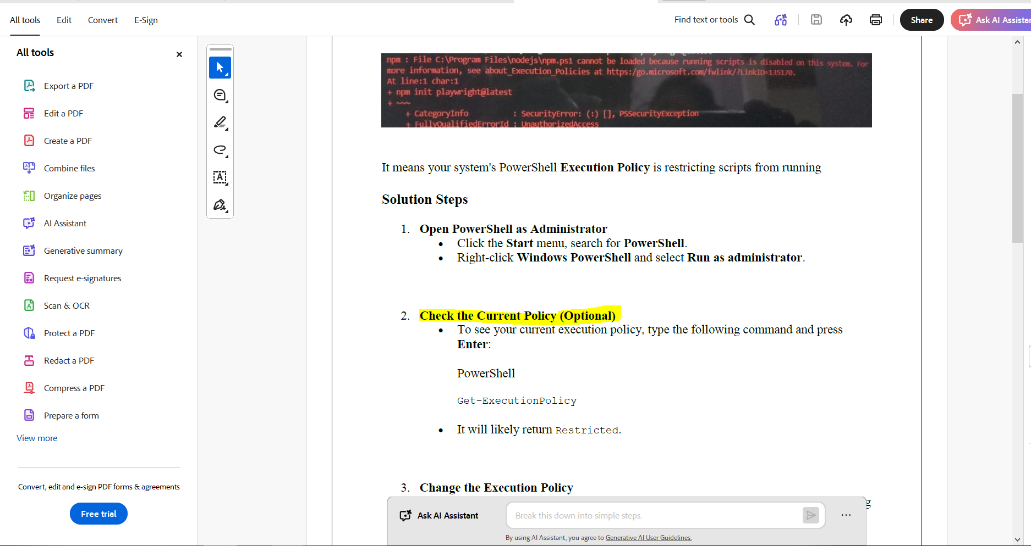
What information is provided in the document regarding AI?
